Event Description

Hong Kong and the current political crisis in the city matters, regardless of where you are.

Come learn more about how this movement began, the relationship between Hong Kong and China, personal stories from the freedom fighters in Hong Kong, and more. This Sunday, October 20, we are inviting locals in the San Francisco Bay Area to participate in and experience:

* A Lennon Wall of colorful sticky notes as a personal platform for people to voice their support and message
* Protest art carrying a message of defiance, but also of hope
* Interactive booths and virtual reality experience of protests

This is a non-religious, family friendly event with childcare and children learning activities. Everyone is welcome. Admission is free. Free street parking near the venue.

MORE DETAILS

Areas

1. Time gallery of the anti-extradition movement
2. Artwork created by Hong Kong volunteers
3. Childcare and art activities for kids
4. Immersive VR experience from Hong Kong Free Press
5. Write your wishes for Hong Kong and fold a freedom crane
6. Refreshments, try Hong Kong local snacks
7. Hang out and have a discussion with Hong Kongers

Interactive Booths

1. 5 Demands, not 1 Less
2. Out Hope For the Next Generation
3. The Root of Resistance
4. Hong Kong VS China: Standing for Freedom
5. Police: Protection or Provocation?
6. 1 in 7 Million: Voices from Hong Kong
7. Stand with Hong Kong, Fight for Freedom

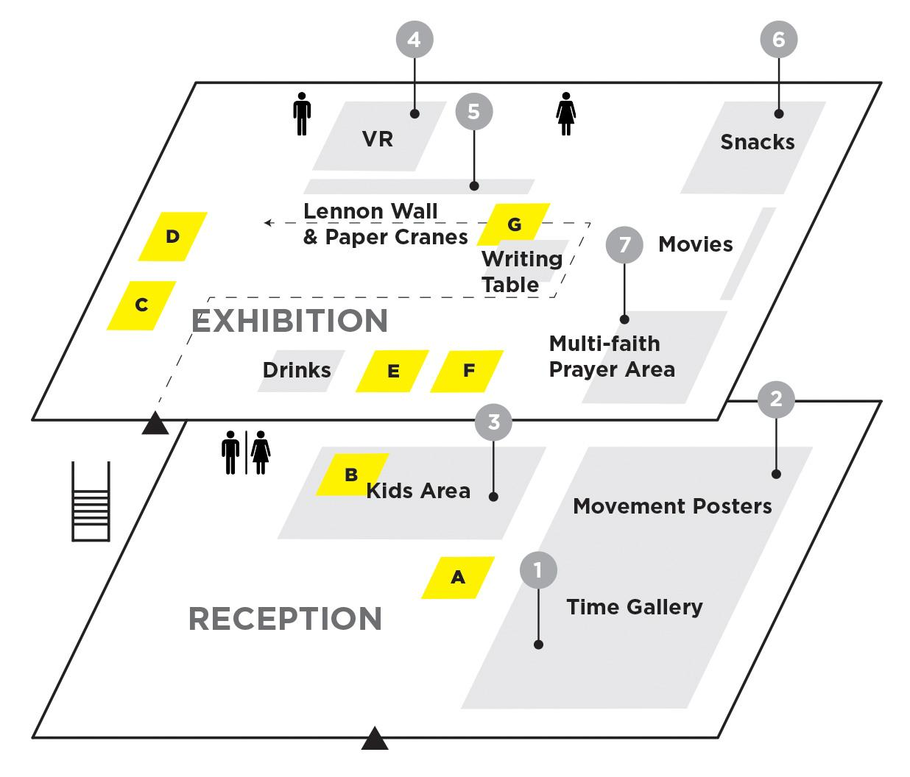

# Old

You are invited to come and learn about the recent unrest in Hong Kong from local Bay Area-Hong Kongers at Channel Church in Berkeley, CA on October 20th from 1PM to 5PM. The expo will cover various topics about this movement like how it all began and the relationship between Hong Kong and China, and disclose many touching stories of the fight for freedom in Hong Kong. This is a family friendly event with childcare and children learning activities.

Everyone is welcomed! Free admission. It is a great opportunity to understand more about the current situation in Hong Kong, to show support to Hong Kongers, and also to meet new friends and share ideas!

HIGHLIGHTS

==========

Child care and family-friendly activities will be provided.

There will be videos, music, an art corner, Lennon wall, photo booth with props, prayer, counseling corners and various artifacts and activities in the expo.

PARKING INFO

============

There will be free street parking near the venue.

Link: https://www.facebook.com/events/936815416672692/